International Bach Academy for Organ 2015
organised around the Chr.Müller organ (1734) of the Waalse Kerk in Amsterdam.
Master Class Jacques van Oortmerssen

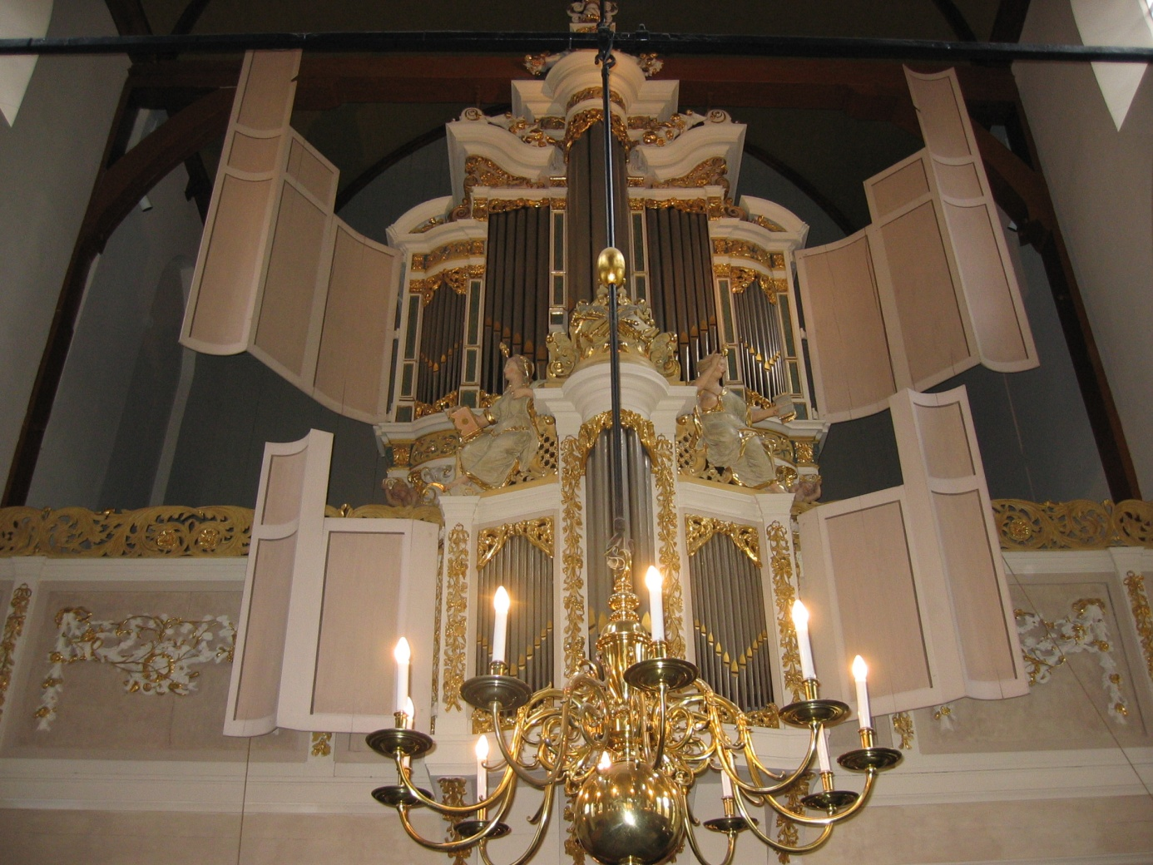
JULY 06 - 09 2015
This course will be organised by the Waalse Kerk in Amsterdam and is open for professional organists and students studying at institutions for professional musical education. Master classes by Jacques van Oortmerssen, professor of organ Conservatorium van Amsterdam during four days (twenty hours in total)
Repertoire by J.S.Bach 1685-1750:
special focus on symbolism in Bach's organ music:
Kyrie, Gott Vater in Ewigkeit BWV 672, Christe, aller Welt Trost BWV 673, Kyrie, Gott heiliger Geist BWV 674, Pièce d'Orgue BWV 572, Orgelbüchlein BWV 599, 618, 622, 631, 637
and one or two works FREE CHOICE!

Tuition fee € 295,-
This fee excludes the cost of hotels and meals!
Only 25 places available!

Enjoy this short video of the 2014 academy: http://www.youtube.com/watch?v=TmjWqHS2cUY

Please send your application by e-mail to Antonetta.Uijl@quicknet.nl containing the following information:
Name:
Address:
City and post code:
Country:
E mail address:
Education:

________________________________________________________

